 

An Autonomous Institution Affiliated to Visvesvaraya Technological University, Belagavi

Approved by UGC/AICTE/Govt of Karnataka, accredited by NAAC - **A+ Grade**, Programs Accredited by NBA (Tier-1)

**DEPARTMENT OF MECHANICAL ENGINEERING**

**Project Report for Project Phase 2 (18MEP79)**

*on*

**Thermal Characterization of Sodium Ion battery-**

**Experimental Study**

### Submitted by

|  |  |  |  |
| --- | --- | --- | --- |
| **Prathm Yadav Borkar** | **VI Sem** | **Section B** | **1NT20ME053** |
| **Dushyanth Chilukuri** | **VI Sem** | **Section B** | **1NT20ME022** |

### Under the guidance of

|  |
| --- |
| **Dr.Ramesh Babu N** |
| Associate Professor |
| Department of Mechanical Engineering |

**Mr. Manjunath HN.**

Assistant Professor

Department of Mechanical Engineering

 

An Autonomous Institution Affiliated to Visvesvaraya Technological University, Belagavi

Approved by UGC/AICTE/Govt of Karnataka, accredited by NAAC - **A+ Grade**, Programs Accredited by NBA (Tier-1)

**DEPARTMENT OF MECHANICAL ENGINEERING**

Certificate

This is to certify that the project entitled **“Thermal Characterization of Sodium Ion battery-Experimental Study” Phase 2 (18MEP79)** report submitted by **Pratham Yadav Borkar (1NT20ME053), Dushyanth Chilukuri (1NT20ME022),** bonafide students of **Nitte Meenakshi Institute of Technology**, **Bengaluru** in partial fulfilment for the award of B.E Degree in **Mechanical Engineering** of the **Visvesvaraya Technological University,** Belagavi, during the academic year **2023-24** is an authentic work carried out by them under my supervision and guidance**.** It is certified that all corrections/suggestions indicated by me have been incorporated in the report submitted to the department library. The project work report has been approved as it satisfies the academic requirements in respect of project work prescribed for the said degree.

Dr Ramesh Babu N Mr. Manjunath HN

Associate Professor Assistant Professor

Dept of Mechanical Engg, NMIT Dept of Mechanical Engg, NMIT

**Dr. Kapilan N**

Professor & Head

Dept of Mechanical Engg, NMIT

**Dr. H C Nagaraj**

Principal, NMIT

|  |  |  |
| --- | --- | --- |
| **Sl. No.** | **Name of the Examiner** | **Signature with Date** |
| 1. |  |  |
| 2 |  |  |

**CONTENTS**

1. INTRODUCTION 5
   1. Introduction 5
   2. Sodium Ion Battery 5
   3. Thermal Management 6
2. LITERATURE REVIEW 6
3. METHODOLOGY 11
   1. Cell packing Configuration 11
   2. Battery Composition 12
   3. Battery Comparison 13
   4. Parameter Extraction 15
   5. Thermal management 16

REFERENCES 19

**LIST OF FIGURES**

**Figure No. Description Page No.**

1 Cylindrical sodium ion battery 6

* 1. Cylindrical battery meshing 12
  2. Parallel Then Series 13
  3. Balancing Currents 13
  4. Battery Management system 14
  5. Series then Parallel 14
  6. Electrolyte and Binders 15

## Introduction

**CHAPTER 1 INTRODUCTION**

With ever growing population, the demand for transportation increases, which can lead to increased use of fossil fuels and greater environmental impact. In areas with high population density, such as cities, the need to improve air quality and reduce traffic congestion may be greater, making the transition to EVs more pressing. Additionally, in countries with large populations, such as China and India, the demand for energy is likely to increase, making the need to reduce dependence on fossil fuels more important. On the other hand, in countries with lower population densities, the need to switch to EVs may be less pressing. Overall, population can be a factor that can influence the need to switch to EVs, but it is not the only one.

Lithium-ion batteries are widely used as the primary source of power in electric vehicles (EVs) because of their high energy density, long cycle life, and relatively low cost. The high energy density of lithium-ion batteries allows for a smaller and lighter battery pack, which in turn, allows for a more aerodynamic and lightweight vehicle. The long cycle life of lithium- ion batteries means that they can be charged and discharged many times before losing capacity, which is important for EVs, as it means that the battery can last for a long time. Additionally, lithium-ion batteries are relatively low cost compared to other battery technologies, which makes them more cost-effective for use in EVs. Overall, lithium-ion batteries offer the best combination of performance, cost, and safety, making them the preferred choice for use in EVs.

Sodium is being researched as a potential alternative to lithium in rechargeable batteries, particularly for use in electric vehicles (EVs), because of its abundance and low cost. Sodium is much more abundant than lithium, making it a more sustainable and cost-effective material for use in batteries. Sodium-ion batteries have the same working principle as lithium-ion batteries, but the use of sodium instead of lithium can make the batteries cheaper to produce.

## Sodium Ion Battery

A sodium ion battery is a type of rechargeable battery that uses sodium ions as the charge carrier instead of lithium ions, which are used in traditional lithium-ion batteries. Sodium ion batteries are being researched as a potential alternative to lithium-ion batteries due to the abundance and low cost of sodium compared to lithium. However, they currently have lower energy densities and shorter lifetimes than lithium-ion batteries.

The operating principle of a sodium-ion battery is similar to that of a lithium-ion battery. Both types of batteries use a cathode and an anode, with an electrolyte in between. During discharge, sodium ions are extracted from the cathode and travel through the electrolyte to the anode, where they are stored. During charging, the process is reversed, and the ions travel back to the cathode. The main difference between the two types of batteries is the type of materials used in the cathode, anode, and electrolyte. In a sodium-ion battery, the cathode is typically made of a sodium-rich material, while the anode is made of carbon. The electrolyte is typically a liquid or gel that contains sodium ions.

Sodium-ion batteries, like all batteries, generate heat during operation. This heat is generated because of the chemical reactions that take place within the battery, such as the movement of ions between the electrodes. The heat generation in sodium-ion batteries can be affected by several factors, including the rate of charge and discharge, the temperature of the battery, and the state of the battery's electrodes.

One of the challenges of sodium-ion batteries is that they tend to generate more heat than lithium-ion batteries, because of the larger ionic radius of sodium ions. This can lead to thermal runaway, a phenomenon where the temperature of the battery increases uncontrollably, which can cause damage to the battery and even lead to a fire.

Thus arises a need for thermal management system for a Sodium ion battery, to ensure it remains functional with good efficiency.

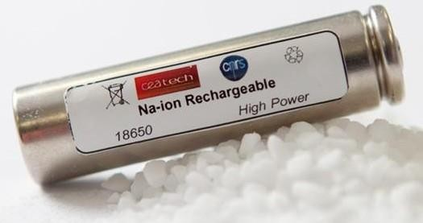

*Figure 1: Cylindrical sodium ion battery*

## Thermal Management:

Thermal management in batteries is the process of controlling and maintaining the temperature of the battery cells within a safe operating range to ensure the performance, safety and longevity of the battery. Batteries, generate heat during operation, and if the temperature becomes too high, it can lead to thermal runaway, a phenomenon where the temperature of the battery increases uncontrollably, which can cause damage to the battery and even lead to a fire.

There are several methods for thermal management in batteries:

Passive methods: This includes the use of thermal insulation materials, such as thermal tapes, to reduce heat loss and increase thermal conductivity.

Active methods: This includes the use of cooling systems, such as air or liquid cooling, to remove heat from the battery and maintain a safe operating temperature.

Combination of both: This method is a combination of passive and active thermal management, where passive methods such as thermal insulation materials are used in conjunction with active methods such as cooling systems to improve thermal management.

Battery Management System (BMS): A BMS can monitor the battery temperature and adjust the charging and discharging parameters accordingly to prevent the battery from getting too hot. Thermal management is a critical aspect of batteries and different methods can be used depending on the specific requirements of the application and the type of battery used.

**CHAPTER 2 LITERATURE REVIEW**

* 1. **Thermal Management**
     + Rajesh Akula, C. Balaji, 2022, has discussed in his paper “Thermal management of 18650 Li-ion battery using novel fins–PCM–EG composite heat sinks”.

The present study introduces a novel fin–Phase Change Material (PCM)–Expanded Graphite (EG) composite for better thermal management of a Panasonic NCR18650BD battery at discharge rates higher than its maximum discharge limit 2C. Fins and EG are augmented with PCM to enhance its effective thermal conductivity.

* + - Chen, K., Hou, J., Song, M., Wang, S., Wu, W., & Zhang, Y. 2019 demonstrated in his paper “Design of battery thermal management system based on phase change material and heat pipe”.

The performance of battery thermal management system (BTMS) with phase change material (PCM) and heat pipe (HP) is studied. The performance of the BTMS is compared to that of the one with solely HP, find that PCM can effectively reduce the temperature difference in battery pack.

* + - Rajesh Akula & Chakravarthy Balaji. 2021 demonstrated in his paper “Effect of PCM fill ratio and heat sink orientation on the thermal management of transient power spikes in electronics”.

To investigate the usefulness of Phase Change Material based heat sinks in power surge operations. Most of the electronic equipment draws high power either during the starting of operation or when they start working on full load conditions.

* + - Tran, M.-K., Cunanan, C., Panchal, S., Fraser, R., Fowler, M. 2021 demonstrated in his paper “Investigation of Individual Cells Replacement Concept in Lithium-Ion Battery Packs with Analysis on Economic Feasibility and Pack Design Requirements”.

This paper used a simulation framework, based on a cell voltage model and a degradation model, to study the feasibility and benefits of the cell replacement concept. It was found that the cell replacement method can increase the total number of cycles of the battery packs, effectively prolonging the lifespan of the packs.

* + - Jingwen Wenga, Dongxu Ouyanga, Xiaoqing Yangb, Mingyi Chenc, Guoqing Zhangb, Jian Wang, 2020, has discussed in his paper “Optimization of the internal fin in a phase-change-material module for battery thermal management”.

An optimized PCM module combining various fins is designed and tested for its thermal performance, where a greater balance between the heat absorption and heat dissipation is obtained with lower maximum battery temperature and smaller temperature range.

* + - Kai Chen, Yiming Chen, Mengxuan Song, Shuangfeng Wang, 2022, has discussed in his paper “Multi-parameter structure design of parallel mini-channel cold plate for battery thermal management”.

Battery pack is cooled by the parallel mini-channel cold plate. The edge width and convergence channel width of the three systems are designed & among the three the performance of the symmetrical PMCPs I & Z is better than symmetrical PMCP U. It is observed that the cooling performance of a parallel mini-channel cold plate can be significantly improved.

* + - Kudakwashe Chayambuka, Ming Jiang, Grietus Mulder, DmitriL. Danilov, Peter

H.L. Notten, 2021, has discussed in his paper “Physics-based modeling of sodium- ion batteries part I: Experimental parameter determination.”

This proclamation is based on recent technological trends and the outstanding performance of the state-of-the-art prototype 18650 and pouch cells. In this contribution, experimental characterizations of SIB electrode materials based on Na3V2(PO4)2F3 (NVPF) cathode and hard carbon (HC) anode are presented. electrodes. Based on the analyses of Na//NVPF and Na//HC half-cells, diffusion mass transport limitations and Ohmic losses are identified for both electrodes.

* + - Kudakwashe Chayambuka, Ming Jiang, Grietus Mulder, DmitriL. Danilov, Peter

H.L. Notten, 2021, has discussed in his paper, “Physics-based modeling of sodium- ion batteries part II. Model and validation”.

Herein, a physics- based, pseudo-two-dimensional (P2D) model is introduced for SIBs. The P2D SIB model is based on Na3V2(PO4)2F3 (NVPF) and hard carbon (HC) as positive and negative electrodes, respectively. It is shown that the model is highly accurate in predicting the discharge profiles of full cell HC//NVPF SIBs. In addition, internal battery states, such as the individual electrode potentials and concentrations, can be obtained from the model at applied currents.

* + - Kudakwashe Chayambuka, Ming Jiang, Grietus Mulder, DmitriL. Danilov, Peter

H.L. Notten, 2021, has discussed in his paper, “Physics-based modeling of sodium- ion batteries part II. Model and validation”.

Herein, a physics- based, pseudo-two-dimensional (P2D) model is introduced for SIBs. The P2D SIB model is based on Na3V2(PO4)2F3 (NVPF) and hard carbon (HC) as positive and negative electrodes, respectively. It is shown that the model is highly accurate in predicting the discharge profiles of full cell HC//NVPF SIBs. In addition, internal battery states, such as the individual electrode potentials and concentrations, can be obtained from the model at applied currents.

**CHAPTER 3 METHODOLOGY**

**3.1 Cell packing configuration.**

**Parallel then Series**

This is the approach used in most passenger car electric vehicles and smaller battery pack designs.

All of the cells working in parallel are joined together in groups and then these are joined in series.

*Figure 3. 1: Thevenin equivalent electrical model of a Na-ion battery*

**Balancing Currents**

In the case of the parallel and then series arrangement there will be balancing currents flowing within the parallel groups of cells. These occur due to small differences in the cells, cooling, connection resistance and how they age. These currents will be there rebalancing the cells.

*Figure 3. 2: Thevenin equivalent electrical model of a Na-ion battery*

**Battery Management System**

One BMS can manage the battery pack as a whole.

*Figure 3. 3: Thevenin equivalent electrical model of a Na-ion battery*

**Series than Parallel**

This approach gives more flexibility for very large packs. The cells are wired together in series to get to the full system voltage, these series strings are then connected in parallel.

*Figure 3. 4: Thevenin equivalent electrical model of a Na-ion battery*

**Balancing Currents**

The current flows between the series strings will flow when the strings are brough together in parallel. Hence it is important to measure the voltage of each string and set limits on the differences. The difficulty occurs if the differences are too great. Then a decision must be made as to whether you isolate parts, or you charge/discharge to bring them into alignment. You could use a pre-charge resistor, but this might take a long time to align the strings.

*Figure 3. 5: Thevenin equivalent electrical model of a Na-ion battery*

**Battery Management System**

One BMS is required to manage each series string, each string is a battery pack in its own right. A master BMS then has to sit over the top managing the total system and having to make decisions on how these are connected together and under what conditions.

*Figure 3. 6: Thevenin equivalent electrical model of a Na-ion battery*

**3.2 Battery Composition**

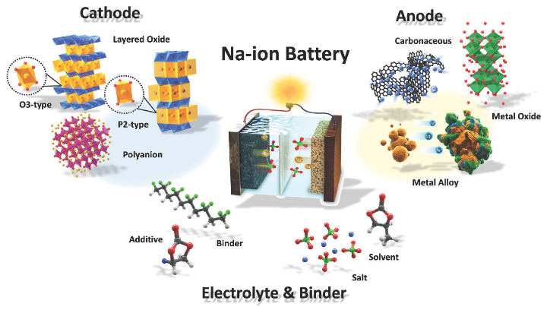

*Figure 3. 7: Electrolyte and Binders*

**ANODE**

1. Carbon-based Materials:

- Hard carbon: Offers 300-360 mAh/g capacity similar to graphite, preferred for its stability and lower working potential.

- Nitrogen-doped hard carbon: Shows larger specific capacity of 520 mAh/g with excellent stability.

2. Graphene:

- Graphene Janus particles: Used to enhance energy density, reaching 337 mAh/g.

3. Carbon Arsenide:

- High specific gravity (794/596mAh/g), low expansion, and ultra-low diffusion barrier, maintaining stability during sodium intercalation.

4. Metal Alloys:

- Nickel antimony (NiSb): Forms a regulating interface on Na metal, reducing overpotential and dendrite formation.

- Various metals (Pb, P, Sn, Ge): Form stable alloys but face issues like volume change and material pulverization.

5. Metals:

- Nano-sized magnesium particles: Achieved 478 mAh/g.

6. Oxides:

- Sodium titanate phases: Deliver capacities of 90-180 mAh/g at low working potentials, but limited cycling stability.

7. Molybdenum Disulfide and TiS2:

- C-MoS2/NCNTs: Stores 348 mAh/g with decent cycling stability.

- Pre-potassiated TiS2: Shows improved rate capability and cycling stability.

Each material presents its unique advantages and challenges in terms of capacity, stability, and cycling performance in sodium-ion batteries*.*

**CATHODE**

1. Oxides:

- Fe and Mn oxides: Sodium-rich compositions deliver 140-190 mAh/g at various discharge voltages, comparable to commercial Li-ion systems.

- Na-rich oxides: Offer capacities around 157-175 mAh/g with compositions containing abundant elements.

- Copper-substituted cathodes: Show improved capacity retention but are more expensive.

2. Oxyanions:

- Sodium vanadium phosphate and fluorophosphate: Exhibit cycling stability with capacities around 120 mAh/g at high discharge voltages.

- Sodium manganese silicate: Delivers high capacity (>200 mAh/g) with decent cycling stability.

3. Prussian Blue and Analogues:

- Na2M[Fe(CN)6] and analogues: Display capacities ranging from 150-209 mAh/g, split between one or two voltage plateaus, with some variants demonstrating good cycling stability.

Each type offers distinct advantages in capacity, cycling stability, and cost, contributing to the diversity of cathode options for sodium-ion batteries.

**3.3 Battery Comparison**

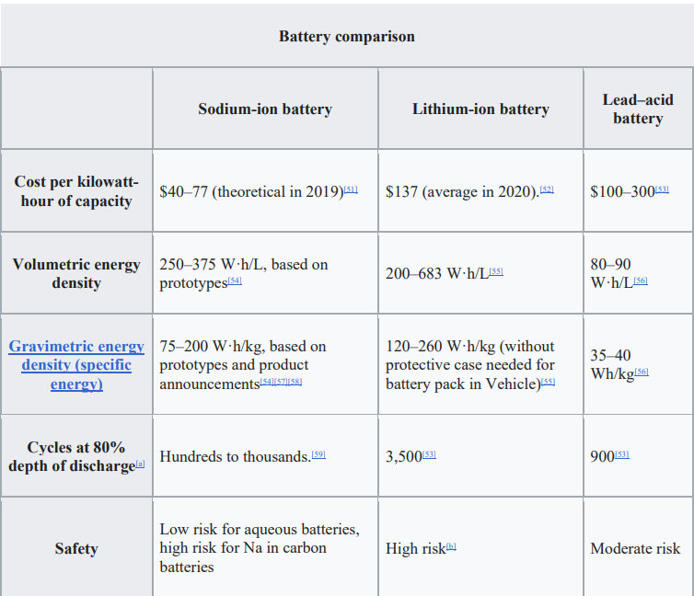

Figure 3.5 Cell in Series

The terminal voltage of the cell is considered stable enough to estimate the OCV of the cell after each 1-hour rest period. The SOC of the cell remains constant during the rest of the period. Experimental plot of pulse discharge test is shown in Figure 3.4. During the SOC range of 20- 100 percent, a 10% SOC declination was set as a target in each of the pulse discharge cycles and a 5% SOC declination was established as a target during the SOC range of 0-20 percent to capture the extremely dynamic behavior of the cell.

For determining the optimal number of branches, the relaxation period for one pulse is taken and fitted against N-exponential curves. The best fit curve is chosen as the optimal value for the number of ranches as shown in the Figure 3.5. The final proposed model uses 2 RC branches where the first RC branch overs fast transients, and the second RC circuit covers slow.

The time gap between the two windows must be long enough to ensure the voltage of the shorter time constant branch should fall very close to zero. The time instant t22 should be at least three times the shorter time constant to ensure the voltage of the shorter time-constant branch has dropped below 5% of its initial value.

The voltage characterization process is used to calculate the values of resistances and capacitances. The SOC of the cell is assumed to be constant during the rest cycle, hence the parameters are determined during the cell’s rest period for each relaxation period. The model parameters were fitted using nonlinear curve fit function which uses non-linear squares method using Levenberg–Marquardt algorithm.

**3.4 Thermal Management**

Based on the heat generated under simulation at different C-rates, a thermal management system can be developed to control and maintain the temperature of the battery cells within a safe operating range. During the simulation, the heat generated by the battery under different C-rates can be measured and analyzed, this data can be used to estimate the heat dissipation requirements for the battery under different operating conditions.

This information can be used to develop a thermal management system that can actively control the temperature of the battery cells and maintain them within a safe operating range, regardless of the C-rate at which the battery is being charged or discharged. This can be done by using active cooling methods, such as air or liquid cooling, or by using a combination of passive and active thermal management methods.

A thermal management system can be an important aspect of battery design and operation, as it can help to prevent thermal runaway, a phenomenon were the temperature of the battery increases uncontrollably, which can cause damage to the battery and even lead to a fire. Additionally, a well-designed thermal management system can help to improve the performance, safety and longevity of the battery.

The battery's heat is controlled using a combination of paraffin wax and expanded graphite. The fins on the battery help to increase the surface area that is in contact with the heat transfer material (PCM), which helps to dissipate the heat away from the battery.

**3.5 HPPC Test**

A typical HPPC data is a set of discharge-charge pulses, applied to a battery at different state of charge (SOC) and at a given temperature. The magnitude of the pulse depends upon the cell capacity and the test temperature. At the end of every sequence of discharge-charge pulse operations, the SOC decreases by about 10% by applying a constant discharge current of C/3. A long rest time of one hour is recommended for the cells to relax after every sequence of discharge-charge pulses. This process continues until it covers all points of interest in the SOC range.

**Test Conditions and Setup**

The cells were tested at five different temperatures: 0*oC*,10*oC*,25*oC*,35*oC*, and 45*oC* chamber temperatures. During the test duration, the temperature was uniform.

These plots show the battery test data. Each test data has nine pairs of discharge-charge pulses. After each discharge-charge operation, a C/3 constant current (SOC sweep step) decreases the cell SOC by 10%

# REFERENCES

1. Rajesh Akula, C. Balaji, 2022, has discussed in his paper “Thermal management of 18650 Li-ion battery using novel fins–PCM–EG composite heat sinks”.
2. Chen, K., Hou, J., Song, M., Wang, S., Wu, W., & Zhang, Y. 2019 demonstrated in his paper “Design of battery thermal management system based on phase change material and heat pipe”.
3. Rajesh Akula & Chakravarthy Balaji. 2021 demonstrated in his paper “ Effect of PCM fill ratio and heat sink orientation on the thermal management of transient power spikes in electronics”.
4. Tran, M.-K., Cunanan, C., Panchal, S., Fraser, R., Fowler, M. 2021 demonstrated in his paper “Investigation of Individual Cells Replacement Concept in Lithium- Ion Battery Packs with Analysis on Economic Feasibility and Pack Design Requirements”.
5. Jingwen Wenga, Dongxu Ouyanga, Xiaoqing Yangb, Mingyi Chenc, Guoqing Zhangb, Jian Wang, 2020, has discussed in his paper “Optimization of the internal fin in a phase-change-material module for battery thermal management”.
6. Kai Chen, Yiming Chen, Mengxuan Song, Shuangfeng Wang, 2022, has discussed in his paper “Multi-parameter structure design of parallel mini- channel cold plate for battery thermal management”.
7. Kudakwashe Chayambuka, Ming Jiang, Grietus Mulder, DmitriL. Danilov, Peter H.L. Notten, 2021, has discussed in his paper “Physics-based modeling of sodium-ion batteries part I: Experimental parameter determination.”
8. Kudakwashe Chayambuka, Ming Jiang, Grietus Mulder, DmitriL. Danilov, Peter H.L. Notten, 2021, has discussed in his paper, “Physics-based modeling of sodium-ion batteries part II. Model and validation”.
9. Kudakwashe Chayambuka, Ming Jiang, Grietus Mulder, DmitriL. Danilov, Peter H.L. Notten, 2021, has discussed in his paper, “Physics-based modeling of sodium-ion batteries part II. Model and validation”.